# FETALAI: USING MACHINE LEARNING

# TO PREDICT AND MONITOR FETAL

# HEALTH

A MINI PROJECT REPORT

Submitted to

**JAWAHARLAL NEHRU TECNOLOGICAL UNIVERSITY, HYDERABAD**

In partial fulfillment of the requirements for the award of the degree of

**BACHELOR OF TECHNOLOGY**

**In**

**COMPUTER SCIENCE AND ENGINEERING**

Submitted By

**AKSHAYA THADABOINA 21UK1A0535**

**VIQUAR FATHIMA 21UK1A0543**

**VINAY MANUGONDA 21UK1A0520**

**SAIKRISHNA GUDA 21UK1A0525**

Under the guidance of

Mrs.T.SUSHMA

Assistant Professor



## DEPARTMENT OF COMPUTER SCIENCE AND ENGINEERING

## VAAGDEVI ENGINEERING COLLEGE

Affiliated to JNTUH, HYDERABAD

BOLLIKUNTA, WARANGAL (T.S) – 506005

**DEPARTMENT OF**

**COMPUTER SCIENCE AND ENGINEERING**

## VAAGDEVI ENGINEERING COLLEGE(WARANGAL)



**CERTIFICATE OF COMPLETION**

**INDUSTRY ORIENTED MINI PROJECT**

This is to certify that the UG Project Phase-1 entitled “FETALAI: USING MACHINE LEARNING TO PREDICT AND MONITOR FETAL HEALTH” is being submitted by AKSHAYA THADABOINA (21UK1A0535), VIQUAR FATHIMA (21UK1A0543)

VINAY MANUGONDA (21UK1A0520), SAIKRISHNA GUDA (21UK1A0525)

in partial fulfillment of the requirements for the award of the degree of Bachelor of Technology in Computer Science & Engineering to Jawaharlal Nehru Technological University Hyderabad during the academic year 2024- 2025.

**Project Guide HOD**

**Mrs. T. Sushma Dr. R. NAVEEN KUMAR**

(Assistant Professor) (Professor)

**External**

# ACKNOWLEDGEMENT

We wish to take this opportunity to express our sincere gratitude and deep sense of respect to our beloved **Dr. SYED MUSTHAK AHAMED,** Principal, Vaagdevi Engineering College for making us available all the required assistance and for his support and inspiration to carry out this UG Project Phase-1 in the institute.

We extend our heartfelt thanks to **Dr. R. NAVEEN KUMAR**, Head of the Department of CSE, Vaagdevi Engineering College for providing us necessary infrastructure and thereby giving us freedom to carry out the UG Project Phase-1.

We express heartfelt thanks to Smart Bridge Educational Services Private Limited,

for their constant supervision as well as for providing necessary information

regarding the UG Project Phase-1 and for their support in completing the UG

Project Phase-1.

We express heartfelt thanks to the guide, **T.SUSHMA,** Assistant professor, Department of CSE for his constant support and giving necessary guidance for completion of this UG Project Phase-1.

Finally, we express our sincere thanks and gratitude to my family members, friends for their encouragement and outpouring their knowledge and experience throughout the thesis.

**AKSHAYA THADABOINA (21UK1A0535)**

**VIQUAR FATHIMA (21UK1A0543)**

**VINAY MANUGONDA (21UK1A0520)**

**SAIKRISHNA GUDA (21UK1A0525)**

**ABSTRACT**

"Fetal AI" refers to the application of artificial intelligence (AI) technologies in the field of fetal health prediction and monitoring during pregnancy. This emerging field utilizes AI algorithms to analyze various data sources like fetal monitoring data, and other data source to assess and predict fetal health outcomes.

AI in fetal health aims to enhance prenatal care by providing more accurate and predictions of fetal health. Machine learning models trained on large datasets enable early detection of abnormalities, such as genetic disorders and fetal growth restrictions, allowing for proactive medical interventions and personalized care plans.

**TABLE OF CONTENTS** :-

1. **INTRODUCTION ...................................................................... 6**
   1. **OVERVIEW… ......................................................................... 6**
   2. **PURPOSE ................................................................................. 6-7**
2. **LITERATURE SURVEY .......................................................... 8**
   1. **EXISTING PROBLEM ........................................................... 8**
   2. **PROPOSED SOLUTION ..................................................... 8**
3. **THEORITICAL ANALYSIS… .............................................. 9**
   1. **BLOCK DIAGRAM ............................................................... 9**
   2. **HARDWARE /SOFTWARE DESIGNING ................... 9-10**
4. **EXPERIMENTAL INVESTIGATIONS ........................... 11-12**
5. **FLOWCHART… ...................................................................... 13**
6. **RESULTS… ......................................................................... 14-18**
7. **ADVANTAGES AND DISADVANTAGES… ....................... 19-20**
8. **APPLICATIONS ...................................................................... 21**
9. **CONCLUSION ......................................................................... 22**
10. **FUTURE SCOPE… .............................................................. 23**
11. **BIBILOGRAPHY ............................................................. 24**
12. **APPENDIX (SOURCE CODE) &CODE SNIPPETS .... 25-63**

## 1.INTRODUCTION

**1.1. OVERVIEW**

Fetal health monitoring and prediction plays a pivotal role in prenatal care, aiming to assess the well-being of the fetus and anticipate potential complications during pregnancy. The ability to accurately predict fetal health status allows healthcare providers to intervene promptly, thereby improving fetal outcomes.

In recent years, the integration of machine learning (ML) and artificial intelligence (AI) techniques has revolutionized the field of fetal health prediction. AI in fetal health aims to enhance prenatal care by providing more accurate and predictions of fetal health. Machine learning models trained on large datasets enable early detection of abnormalities, such as genetic disorders and fetal growth restrictions, allowing for proactive medical interventions and personalized care plans.

**1.2. PURPOSE**

1. **Enhance Early Detection**: Identify fetal health issues at an early stage to facilitate timely medical intervention and reduce the risk of complications during pregnancy and childbirth.

2. **Improve Diagnostic Accuracy**: Utilize machine learning algorithms to analyze complex patterns in cardiotocographic (CTG) data, leading to more accurate and reliable predictions compared to traditional methods.

3. **Support Healthcare Providers**: Assist obstetricians and healthcare professionals by providing a data-driven decision support system that can help in diagnosing and managing fetal health conditions.

4. **Reduce Fetal Mortality**: By accurately predicting and addressing potential health issues early, the technology aims to decrease the rates of fetal mortality and morbidity.

5. **Optimize Resource Allocation**: Help in prioritizing and allocating medical resources more effectively by identifying high-risk pregnancies that require closer monitoring and intervention.

6. **Advance Medical Research**: Contribute to the body of knowledge in prenatal medicine by uncovering new insights and patterns in fetal health data through advanced analytical techniques.

## 

## 

## 

## 2. LITERATURE SURVEY

**2.1 EXISTING PROBLEM**

The fetal health situation in India and globally is a significant and the most critical problem in the medical field. In India, there are many challenges such as limited access to quality prenatal care, high infant mortality rates that contribute to adverse fetal health outcomes. Issues such as low birth weight, premature births, and congenital anomalies pose risks to the well-being of fetuses.

Fetal health monitoring traditionally relies on periodic check-ups and ultrasound scans, which may not provide real-time and continuous insights into the well-being of the fetus. Early detection of potential complications based on individual data is limited.

Conventional methods like ultrasound imaging, periodic physical examinations have provided valuable insights but are limited in terms of real-time monitoring, accurate prediction. They often rely on manual interpretation and lack the ability to leverage advanced data analysis techniques.

**2.2 PROPOSED SOLUTION**

The proposed solution is to employ machine learning algorithms and data analysis techniques to develop a predictive model that can continuously monitor and predict fetal health based on data.

This AI-based approach utilizes a comprehensive dataset, including ultrasound measurements, other relevant data points to train the model.

The developed predictive model makes use of machine learning methods to uncover trends and connections in the dataset. It uses feature engineering approaches to identify the most useful features for precise predictions and extract meaningful information from the gathered data. Using accessible data, the model is trained and verified, establishing its performance and robustness. By utilizing this proposed solution, healthcare professionals can benefit from early detection of potential complications, continuous real-time monitoring, improved decision-making based on accurate predictions.

## 3.THEORITICAL ANALYSIS

**3.1. BLOCK DIAGRAM**

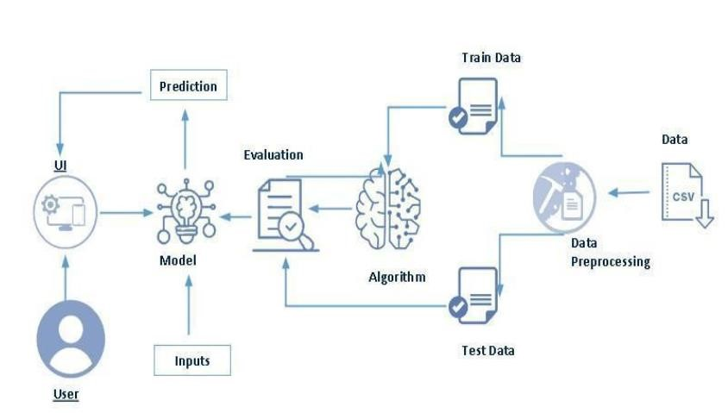

**3.2. SOFTWARE DESIGNING**

The following is the Software required to complete this project:

* **Google Colab**: Google Colab will serve as the development and execution environment for your predictive modeling, data preprocessing, and model training tasks. It provides a cloud-based Jupyter Notebook environment with access to Python libraries and hardware acceleration.
* **Dataset (CSV File)**: The dataset in CSV format is essential for training and testing your predictive model.
* **Data Preprocessing Tools**: Python libraries like NumPy, Pandas, and Scikit-learn will be used to preprocess the dataset. This includes handling missing data, feature scaling, and data cleaning.
* **Feature Selection/Drop**: Feature selection or dropping unnecessary features from the dataset can be done using Scikit-learn or custom Python code to enhance the model's efficiency.
* **Model Training Tools**: Machine learning libraries such as Scikit-learn will be used to develop, train, and fine-tune the predictive model. Depending on the nature of the fetal health prediction task, classification method is considered.
* **Model Accuracy Evaluation**: After model training, accuracy and performance evaluation tools, you'll measure the model's ability to predict fetal health based on data.
* **UI Based on Flask Environment**: Flask, a Python web framework, will be used to develop the user interface (UI) for the system. The Flask application will provide a user-friendly platform for users to view fetal health predictions.
* Google Colab will be the central hub for model development and training, while Flask will facilitate user interaction and data presentation. The dataset, along with data preprocessing, will ensure the quality of the training data, and feature selection will optimize the model. Finally, model accuracy evaluation will confirm the system's predictive capabilities, allowing users to rely on the fetal health predictions.

## 4.EXPERIMENTAL INVESTIGATION

In this project, we have used Fetal Health Classification Dataset. This dataset is a csv file consisting of labelled data and having the following columns:

1. baseline value: It is value of heart rate of fetus.

2. accelerations: It is short-term rises in the heart rate.

3. fetal_movement: It is movement of fetus.

4. uterine_contractions: It is the tightening and shortening of the uterine muscles.

5. light_decelerations: It is temporary decrease in fetal heart rate for short time.

6. severe_decelerations: It is temporary but distinct decrease in fetal heart rate.

7. prolongued_decelerations: It is abnormal fetal heart rate lasts for long time.

8. abnormal_short_term_variability: It is irregularities in the fetal heart rate that deviate from the normal range of variability over short periods.

9. mean_value_of_short_term_variability: It is average amount of fluctuation or variation over a short time period.

10. percentage_of_time_with_abnormal_long_term_variability: It is percentage of time with deviations in variability over longer periods.

11. mean_value_of_long_term_variability: It is average amount of fluctuation or variation over a long time period.

Histograms are good for showing general distributional features of dataset variables.

12. histogram_width

13. histogram_min

14. histogram_max

15. histogram_number_of_peaks

16. histogram_number_of_zeroes

17. histogram_mode

18. histogram_mean

19. histogram_median

20. histogram_variance

21. histogram_tendency

22. fetal_health: It consists health condition of fetus that is normal, suspect, pathological.

For the dataset we selected, it consists of more than the columns we want to predict it . So, we have chosen the feature select it contains the columns that we are going to predict the fetal health.

* Feature select means it selects the columns that we want in our dataset.

Feature_select = ["prolongued_decelerations", "abnormal_short_term_variability", "percentage_of_time_with_abnormal_long_term_variability", "histogram_variance", "histogram_median", "mean_value_of_long_term_variability", "histogram_mode", "accelerations"]

**5.FLOWCHART**

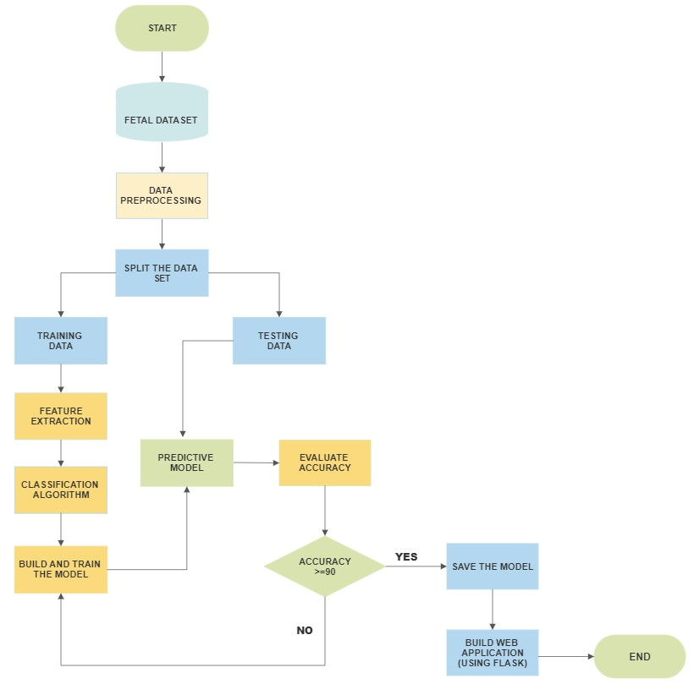

**6.RESULT**

**HOME PAGE**

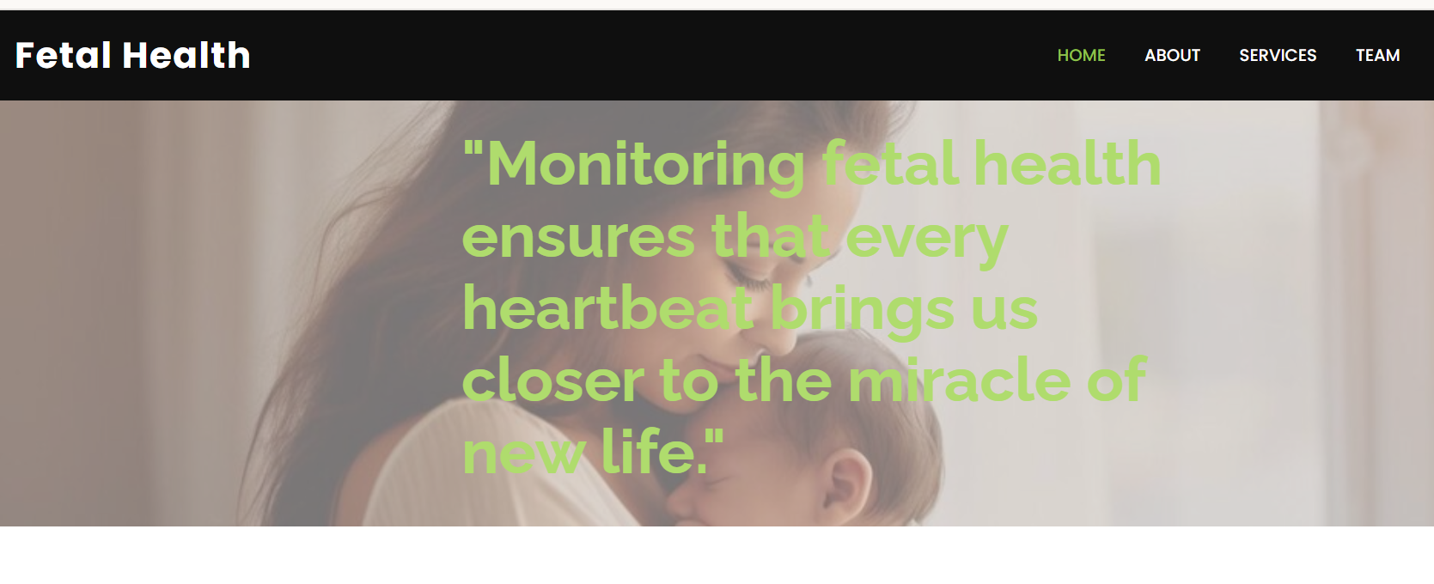

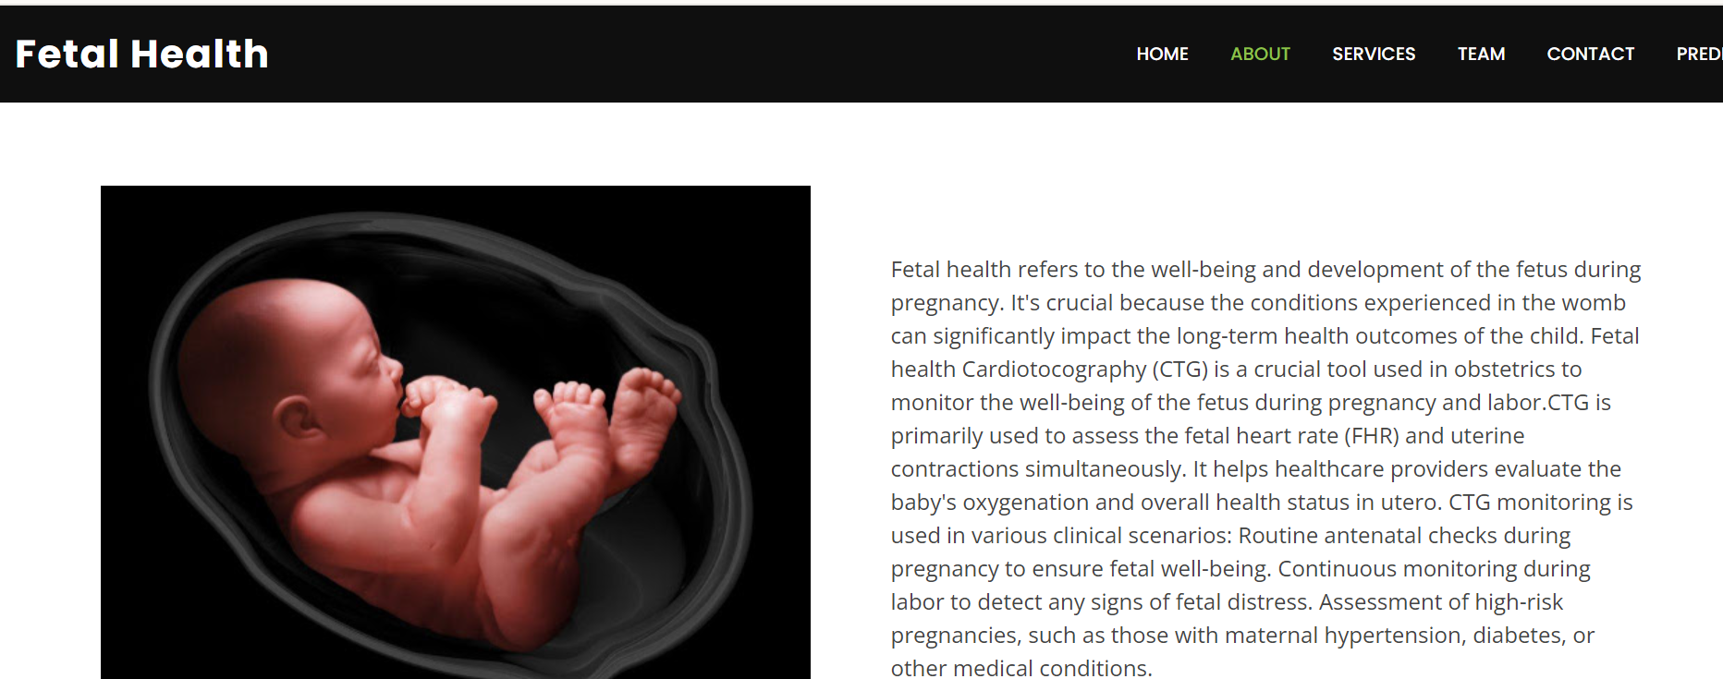

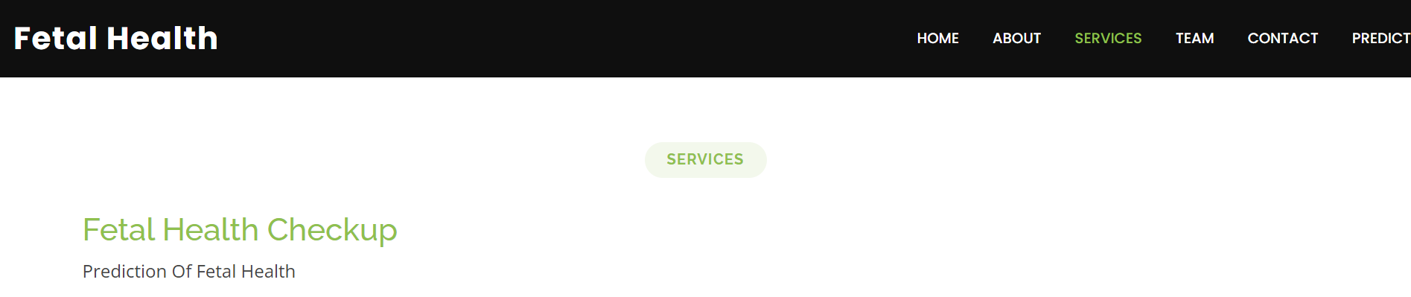

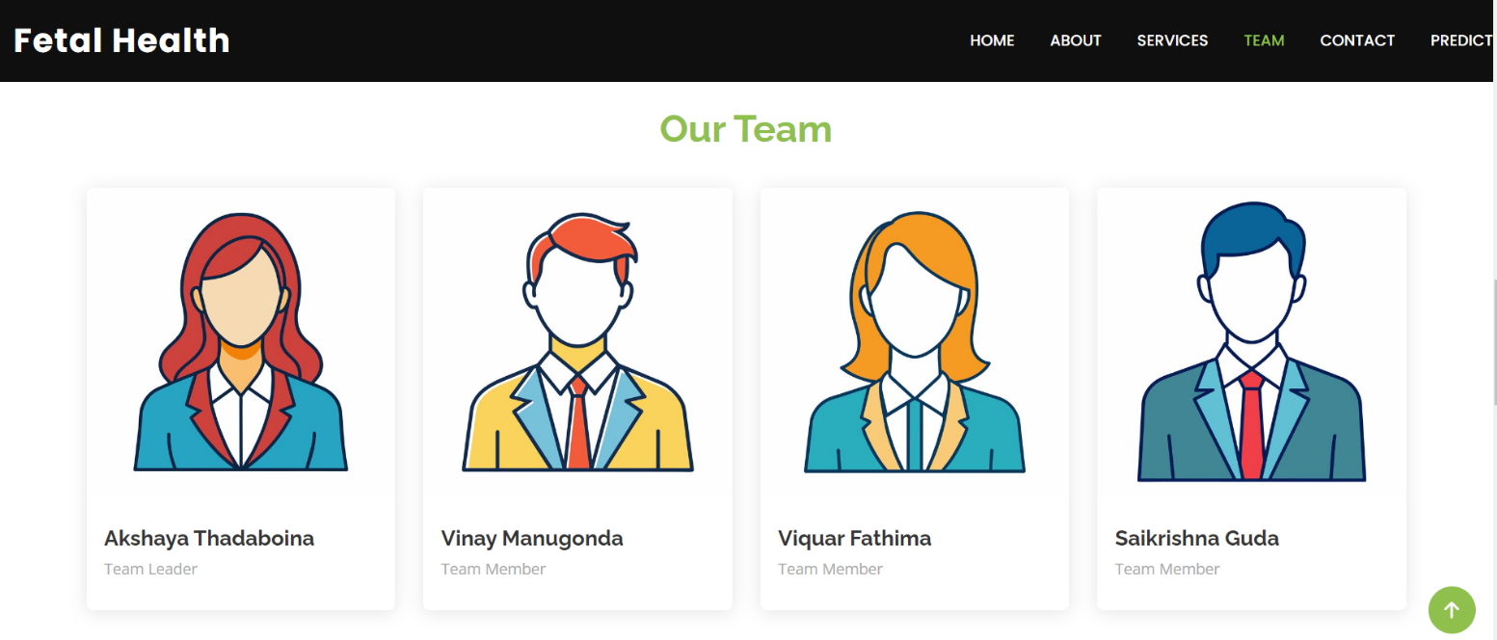

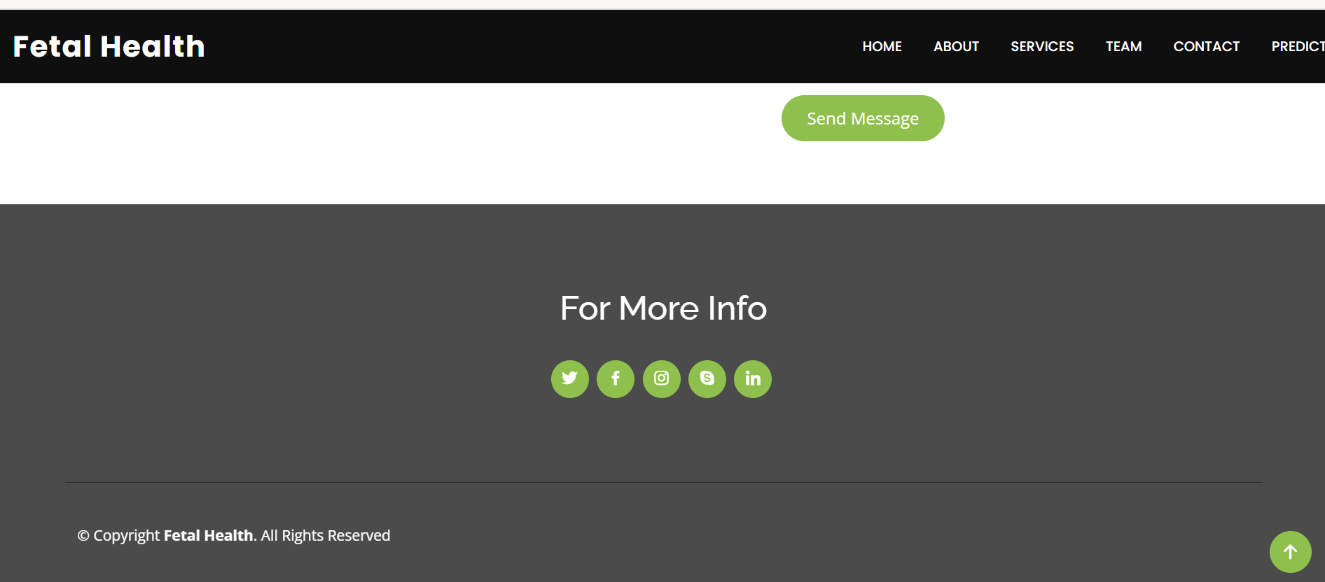

**PREDICTIONS**

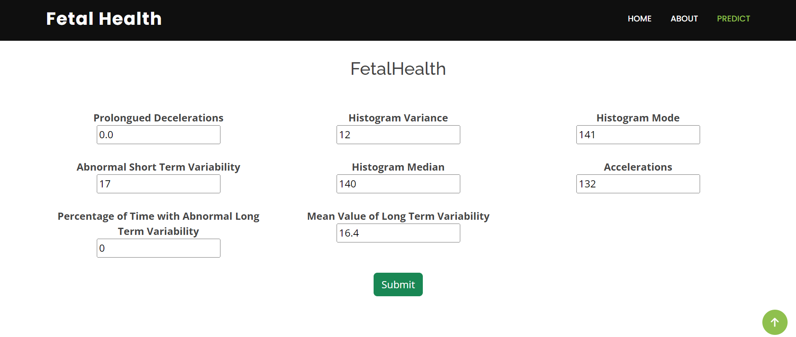

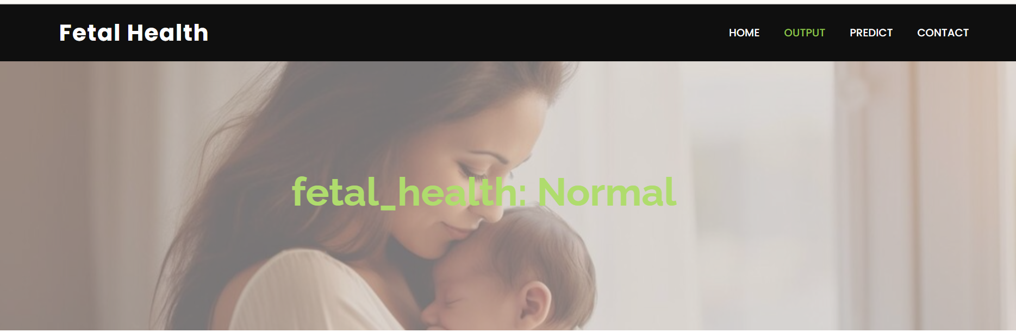

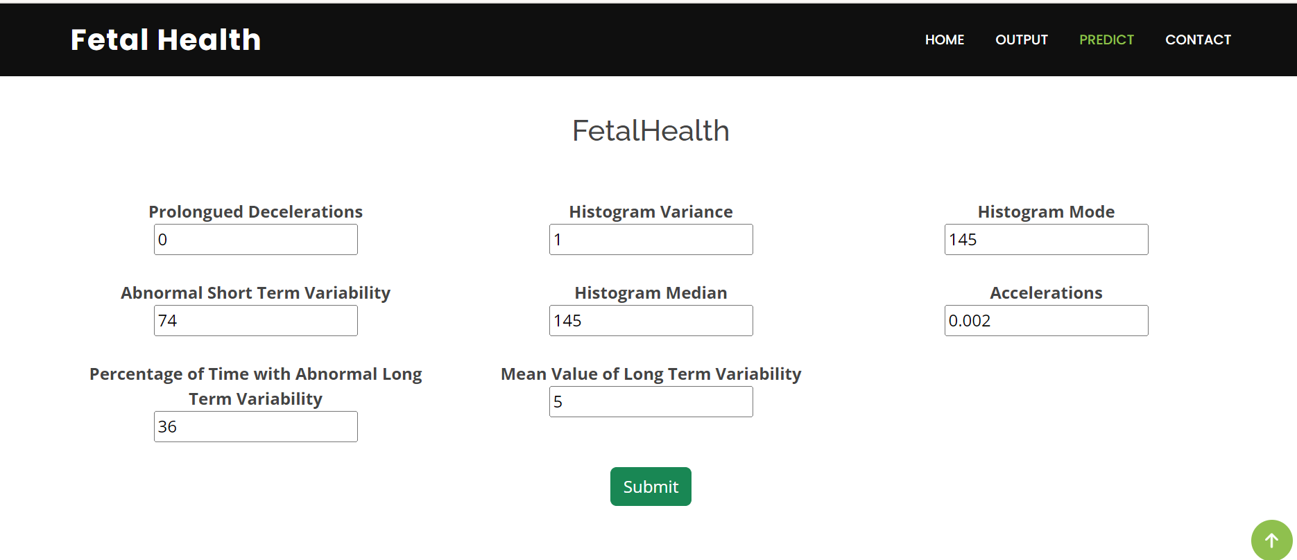







## 7.ADVANTAGES AND DISADVANTAGES

**ADVANTAGES:**

**Early Intervention**: Early prediction of fetal health issues allows healthcare providers to intervene promptly, potentially preventing complications or minimizing their impact. This could include adjusting the mother's lifestyle, starting specific treatments, or planning for specialized care after birth.

**Improving Accuracy and Reliability**: AI enhances the accuracy and reliability of predicting fetal health. Machine learning models can process complex data patterns and provide more precise results.

**Reduced Anxiety and Stress**: For expecting parents, having information about the fetal health can reduce anxiety and stress associated with uncertainty. Knowing that the fetus is healthy or being prepared for potential challenges can provide emotional reassurance.

**Education and Support**: Parents can be educated about the condition affecting the fetus. This empowers them to make informed decisions about the pregnancy and the care of their child after birth.

**Research and Development**: Advances in fetal health prediction contribute to ongoing research and development in prenatal diagnostics and treatments. This continuous improvement leads to better healthcare practices and outcomes for both mothers and babies.

**DISADVANTAGES:**

**Data Availability**: The accuracy and performance of Fetal AI heavily depend on the availability of high-quality and diverse datasets. Limited or biased data could impact the system's effectiveness.

**Technical Challenges**: Implementing and maintaining Fetal AI may pose technical challenges, including data integration from different sources, model training, and ongoing system updates.

**Ethical Considerations**: The use of AI in healthcare raises ethical concerns regarding privacy, data security, informed consent, and potential biases in decision-making. Safeguards and regulatory measures must be in place to address these concerns.

**Impact on Parent-Child Relationship**: In cases where fetal health predictions indicate a significant health issue, parents may experience heightened stress and emotional turmoil, which could potentially impact the parent-child bonding process after birth.

## 8.APPLICATIONS

**Monitoring Fetal Growth and Development**: Ultrasound imaging and other monitoring techniques help assess fetal growth, organ development, and overall health. This information is crucial for detecting intrauterine growth restriction (IUGR), abnormalities in fetal anatomy, and signs of developmental delays.

**Detection of Fetal Anomalies**: Advanced imaging technologies, such as 3D and 4D ultrasound, magnetic resonance imaging (MRI), and fetal echocardiography, aid in detecting structural abnormalities and congenital anomalies in the fetus. Early detection allows for timely medical interventions and planning for specialized care after birth.

**Assessment of Fetal Well-Being**: Non-invasive tests like fetal heart rate monitoring (cardiotocography) and fetal movement counting help assess fetal well-being and detect signs of distress or abnormalities that may indicate the need for closer monitoring or medical intervention.

**Counseling and Parental Education**: Predictive tests provide parents with valuable information about the health status of their unborn child, enabling them to make informed decisions about pregnancy management, birth planning, and potential treatment options.

**Research and Population Studies**: Fetal AI can contribute to research studies and population health monitoring by analyzing large datasets, identifying trends, and generating insights into fetal health outcomes.

## 9.CONCLUSION

## In conclusion, fetal health monitoring using ML algorithms is a pivotal advancement in fetal health. ML algorithms enable accurate predictions and help in enhance the overall quality of care. The use of ML in fetal health monitoring empowers healthcare providers to detect potential risks and complications early on, allowing for timely interventions.

## By analyzing patterns and relationships within the data, ML algorithms can identify subtle anomalies and deviations that might go unnoticed by human observation alone. This proactive approach to fetal health promotes better health outcomes for the developing fetus.

## Fetal AI has the potential to revolutionize pregnancy management and contribute significantly to healthier pregnancies and improved outcomes babies worldwide.

## 10.FUTURE SCOPE

**Integration of Multi-Modal Data**: Future advancements in fetal AI will focus on integrating diverse data sources—from genomic data to maternal physiological parameters and environmental factors—to provide a holistic view of maternal-fetal health. This comprehensive approach enhances predictive modeling capabilities and facilitates tailored interventions based on individualized risk profiles.

**Real-Time Monitoring and Decision Support**: AI technologies will enable real-time monitoring of fetal health parameters, such as heart rate variability and movement patterns, through wearable devices and remote monitoring systems. AI-driven decision support tools will assist healthcare providers in interpreting data trends, making informed clinical decisions, and optimizing management strategies during pregnancy.

**Telemedicine and Remote Care**: Fetal AI holds promise for expanding access to specialized prenatal care through telemedicine platforms. AI-powered diagnostic tools and decision support systems can facilitate remote consultations, enhance collaborative care between healthcare providers, and empower expectant parents with access to expert advice and personalized guidance regardless of geographic location.

**Ethical and Regulatory Considerations**: As fetal AI technologies advance, addressing ethical concerns surrounding data privacy, informed consent, algorithm transparency, and equitable access to AI-driven healthcare solutions will be critical. Ethical frameworks and regulatory guidelines must evolve alongside technological innovations to ensure responsible deployment and use of AI in prenatal care.

**Research and Innovation**: Ongoing research efforts will continue to drive innovation in fetal AI, exploring novel applications such as predictive modeling of neurodevelopmental outcomes, early detection of placental dysfunction, and personalized risk assessment based on maternal and fetal genomics. Collaborative partnerships between academia, industry, and healthcare institutions will foster interdisciplinary approaches to advancing fetal AI technologies.

**11.BIBILOGRAPHY**

[1] Tjoa, A. M., et al. (2019). Machine learning for fetal health prediction in the context of non invasive prenatal testing. IEEE Journal of Biomedical and Health Informatics, 23(4), 1427-1437.

[2] Yilmaz, E., et al. (2020). Prediction of fetal distress using machine learning algorithms. International Journal of Medical Informatics, 136, 104069.

[3] Prabhakar, A., & Shah, A. (2019). Comparative analysis of machine learning algorithms for fetal health prediction. Journal of Biomedical Informatics, 98, 103282.

[4] Raghupathi, W., & Raghupathi, V. (2014). Big data analytics in healthcare: Promise and potential. Health Information Science and Systems, 2(1), 3.

[5] Chauhan, N., Chauhan, D., & Tiwari, P. (2018). Fetal health monitoring using machine learning algorithms: A systematic review. International Journal of Computer Science and Network Security, 18(7), 64-71.

[6] Soomro, T. R., & Khatoon, S. (2021). Fetal health monitoring using machine learning: A systematic literature review. IEEE Access, 9, 52225-52237.

[7] Singh, N., & Sahoo, G. (2020). Prediction of fetal health using machine learning techniques: A systematic review. In Advances in Intelligent Systems and Computing (Vol. 1052, pp. 380-389). Springer.

[8] Nandini, K. V., et al. (2022). Fetal health prediction using machine learning: A review. Journal of Intelligent & Fuzzy Systems, 42(2), 2051-2066.

[9] Kumar, A., & Tripathi, M. (2020). Fetal health prediction using machine learning techniques: A comprehensive review. Journal of Medical Systems, 44(4), 1-16.

[10] Shah, A., & Acharya, U. R. (2019). Fetal health state prediction using machine learning algorithms. In Biomedical Signal and Image Processing (pp. 223-238). CRC Press.

**12.APPENDIX**

**Model building :**

1)Dataset

2)Google colab and Spyder Application Building

HTML file (Index file, Inspect file, Output file)

Models in pickle format

**SOURCE CODE:**

**INDEX.HTML**

<!DOCTYPE html>

<html lang="en">

<head>

<meta charset="utf-8">

<meta content="width=device-width, initial-scale=1.0" name="viewport">

<title>Fetal Health</title>

<meta content="" name="description">

<meta content="" name="keywords">

<!-- Favicons -->

<link href="../static/assets/img/icon.jpg" rel="icon">

<!-- Google Fonts -->

<link href="https://fonts.googleapis.com/css?family=Open+Sans:300,300i,400,400i,600,600i,700,700i|Raleway:300,300i,400,400i,500,500i,600,600i,700,700i|Poppins:300,300i,400,400i,500,500i,600,600i,700,700i" rel="stylesheet">

<!-- Vendor CSS Files -->

<link href="../static/assets/vendor/aos/aos.css" rel="stylesheet">

<link href="../static/assets/vendor/bootstrap/css/bootstrap.min.css" rel="stylesheet">

<link href="../static/assets/vendor/bootstrap-icons/bootstrap-icons.css" rel="stylesheet">

<link href="../static/assets/vendor/boxicons/css/boxicons.min.css" rel="stylesheet">

<link href="../static/assets/vendor/glightbox/css/glightbox.min.css" rel="stylesheet">

<link href="../static/assets/vendor/swiper/swiper-bundle.min.css" rel="stylesheet">

<!-- Template Main CSS File -->

<link href="../static/assets/css/style.css" rel="stylesheet">

</head>

<body>

<!-- ======= Header ======= -->

<header id="header" class="d-flex align-items-center">

<div class="container d-flex justify-content-between">

<div class="logo">

<h1 class="text-light"><a href="index.html">Fetal Health</a></h1>

</div>

</div>

<nav id="navbar" class="navbar">

<ul>

<li><a class="nav-link scrollto active" href="/#hero">Home</a></li>

<li><a class="nav-link scrollto" href="/#about">About</a></li>

<li><a class="nav-link scrollto" href="/#services">Services</a></li>

<li><a class="nav-link scrollto" href="/#team">Team</a></li>

<li><a class="nav-link scrollto" href="/#contact">Contact</a></li>

<a href="/inspect" class="get-started-btn scrollto">Predict</a>

<i class="bi bi-list mobile-nav-toggle"></i>

</nav><!-- .navbar -->

</div>

</header><!-- End Header -->

<!-- ======= Hero Section ======= -->

<section id="hero" class="d-flex align-items-center justify-content-center">

<div class="container" data-aos="fade-up">

<div class="row justify-content-center" data-aos="fade-up" data-aos-delay="150">

<div class="col-xl-6 col-lg-8">

<h1><span>"Monitoring fetal health ensures that every heartbeat brings us closer to the miracle of new life."</span></h1>

</div>

</div>

</div>

</section><!-- End Hero -->

<main id="main">

<!-- ======= About Section ======= -->

<section id="about" class="about">

<div class="container" data-aos="fade-up">

<div class="row">

<div class="features-image col-lg-6" data-aos="fade-up" data-aos-delay="100"><img src="../static/assets/img/fetus.jpg" alt=""></div>

<div class="col-lg-6">

<br>

<br>

Fetal health refers to the well-being and development of the fetus during pregnancy. It's crucial because the conditions experienced in the womb can significantly impact the long-term health outcomes of the child.

Fetal health Cardiotocography (CTG) is a crucial tool used in obstetrics to monitor the well-being of the fetus during pregnancy and labor.CTG is primarily used to assess the fetal heart rate (FHR) and uterine contractions simultaneously. It helps healthcare providers evaluate the baby's oxygenation and overall health status in utero.

CTG monitoring is used in various clinical scenarios:

Routine antenatal checks during pregnancy to ensure fetal well-being.

Continuous monitoring during labor to detect any signs of fetal distress.

Assessment of high-risk pregnancies, such as those with maternal hypertension, diabetes, or other medical conditions.

</div>

</div>

</div>

</div>

</section><!-- End about Section -->

<!-- ======= Services Section ======= -->

<section id="services" class="services">

<!-- Section Title -->

<div class="container section-title" data-aos="fade-up">

<h2>Services</h2>

</div><!-- End Section Title -->

<div class="container">

<div class="row gy-4">

<div class="col-lg-4 col-md-6" data-aos="fade-up" data-aos-delay="400">

<div class="service-item position-relative">

</div>

<a href="/inspect" class="stretched-link">

<h3>Fetal Health Checkup</h3>

</a>

<p>Prediction Of Fetal Health</p>

</div>

</div><!-- End Service Item -->

</div>

</div>

</section><!-- End Services Section -->

<!-- ======= Team Section ======= -->

<section id="team" class="team">

<div class="container">

<div class="section-title" data-aos="zoom-in">

<h3><span>Our Team</span></h3>

</div>

<div class="row">

<div class="col-lg-3 col-md-6 d-flex align-items-stretch">

<div class="member" data-aos="fade-up">

<div class="member-img">

<img src="../static/assets/img/team/1.jpg" class="img-fluid" alt="">

<div class="social">

<a href=""><i class="bi bi-twitter"></i></a>

<a href=""><i class="bi bi-facebook"></i></a>

<a href=""><i class="bi bi-instagram"></i></a>

<a href=""><i class="bi bi-linkedin"></i></a>

</div>

</div>

<div class="member-info">

<h4>Akshaya Thadaboina</h4>

<span>Team Leader</span>

</div>

</div>

</div>

<div class="col-lg-3 col-md-6 d-flex align-items-stretch">

<div class="member" data-aos="fade-up">

<div class="member-img">

<img src="../static/assets/img/team/2.jpg" class="img-fluid" alt="">

<div class="social">

<a href=""><i class="bi bi-twitter"></i></a>

<a href=""><i class="bi bi-facebook"></i></a>

<a href=""><i class="bi bi-instagram"></i></a>

<a href=""><i class="bi bi-linkedin"></i></a>

</div>

</div>

<div class="member-info">

<h4>Vinay Manugonda</h4>

<span>Team Member</span>

</div>

</div>

</div>

<div class="col-lg-3 col-md-6 d-flex align-items-stretch">

<div class="member" data-aos="fade-up">

<div class="member-img">

<img src="../static/assets/img/team/3.jpg" class="img-fluid" alt="">

<div class="social">

<a href=""><i class="bi bi-twitter"></i></a>

<a href=""><i class="bi bi-facebook"></i></a>

<a href=""><i class="bi bi-instagram"></i></a>

<a href=""><i class="bi bi-linkedin"></i></a>

</div>

</div>

<div class="member-info">

<h4>Viquar Fathima</h4>

<span>Team Member</span>

</div>

</div>

</div>

<div class="col-lg-3 col-md-6 d-flex align-items-stretch">

<div class="member" data-aos="fade-up">

<div class="member-img">

<img src="../static/assets/img/team/4.jpg" class="img-fluid" alt="">

<div class="social">

<a href=""><i class="bi bi-twitter"></i></a>

<a href=""><i class="bi bi-facebook"></i></a>

<a href=""><i class="bi bi-instagram"></i></a>

<a href=""><i class="bi bi-linkedin"></i></a>

</div>

</div>

<div class="member-info">

<h4>Saikrishna Guda</h4>

<span>Team Member</span>

</div>

</div>

</div>

</div>

</div>

</section><!-- End Team Section -->

<!-- ======= Contact Section ======= -->

<section id="contact" class="contact">

<div class="container">

<div class="section-title" data-aos="zoom-in">

<h3><span>Contact Details</span></h3>

</div>

<div class="row mt-5">

<div class="col-lg-4" data-aos="fade-right">

<div class="info">

<div class="address">

<i class="bi bi-geo-alt"></i>

<h4>Location:</h4>

<p>Vaagdevi Engineering College, Bollikunta, Warangal</p>

</div>

<div class="email">

<i class="bi bi-envelope"></i>

<h4>Email:</h4>

<p>info@FetalHealth.com</p>

</div>

<div class="phone">

<i class="bi bi-phone"></i>

<h4>Call:</h4>

<p>+91 6304320044</p>

</div>

</div>

</div>

<div class="col-lg-8 mt-5 mt-lg-0">

<form action="forms/contact.php" method="post" role="form" class="php-email-form">

<div class="row">

<div class="col-md-6 form-group">

<input type="text" name="name" class="form-control" id="name" placeholder="Your Name" required>

</div>

<div class="col-md-6 form-group mt-3 mt-md-0">

<input type="email" class="form-control" name="email" id="email" placeholder="Your Email" required>

</div>

</div>

<div class="form-group mt-3">

<input type="text" class="form-control" name="subject" id="subject" placeholder="Subject" required>

</div>

<div class="form-group mt-3">

<textarea class="form-control" name="message" rows="5" placeholder="Message" required></textarea>

</div>

<div class="my-3">

<div class="loading">Loading</div>

<div class="error-message"></div>

<div class="sent-message">Your message has been sent. Thank you!</div>

</div>

<div class="text-center"><button type="submit">Send Message</button></div>

</form>

</div>

</div>

</div>

</section><!-- End Contact Section -->

</main><!-- End #main -->

<!-- ======= Footer ======= -->

<footer id="footer">

<div class="footer-top">

<div class="container">

<div class="row justify-content-center">

<div class="col-lg-6">

</div>

</div>

<div><h2>For More Info</h2></div>

<div class="social-links">

<a href="#" class="twitter"><i class="bx bxl-twitter"></i></a>

<a href="#" class="facebook"><i class="bx bxl-facebook"></i></a>

<a href="#" class="instagram"><i class="bx bxl-instagram"></i></a>

<a href="#" class="google-plus"><i class="bx bxl-skype"></i></a>

<a href="#" class="linkedin"><i class="bx bxl-linkedin"></i></a>

</div>

</div>

</div>

<div class="container footer-bottom clearfix">

<div class="copyright">

&copy; Copyright <strong><span>Fetal Health</span></strong>. All Rights Reserved

</div>

</div>

</footer><!-- End Footer -->

<div id="preloader"></div>

<a href="#" class="back-to-top d-flex align-items-center justify-content-center"><i class="bi bi-arrow-up-short"></i></a>

<!-- Vendor JS Files -->

<script src="../static/assets/vendor/purecounter/purecounter_vanilla.js"></script>

<script src="../static/assets/vendor/aos/aos.js"></script>

<script src="../static/assets/vendor/bootstrap/js/bootstrap.bundle.min.js"></script>

<script src="../static/assets/vendor/glightbox/js/glightbox.min.js"></script>

<script src="../static/assets/vendor/isotope-layout/isotope.pkgd.min.js"></script>

<script src="../static/assets/vendor/swiper/swiper-bundle.min.js"></script>

<script src="../static/assets/vendor/php-email-form/validate.js"></script>

<!-- Template Main JS File -->

<script src="../static/assets/js/main.js"></script>

</body>

</html>

**INSPECT.HTML**

<!DOCTYPE html>

<html lang="en">

<head>

<meta charset="utf-8">

<meta content="width=device-width, initial-scale=1.0" name="viewport">

<title>Inner Page - Remember Bootstrap Template</title>

<meta content="" name="description">

<meta content="" name="keywords">

<!-- Favicons -->

<link href="../static/assets/img/icon.jpg" rel="icon">

<!-- Google Fonts -->

<link href="https://fonts.googleapis.com/css?family=Open+Sans:300,300i,400,400i,600,600i,700,700i|Raleway:300,300i,400,400i,500,500i,600,600i,700,700i|Poppins:300,300i,400,400i,500,500i,600,600i,700,700i" rel="stylesheet">

<!-- Vendor CSS Files -->

<link href="../static/assets/img/icon.jpg" rel="icon">

<link href="../static/assets/vendor/bootstrap/css/bootstrap.min.css" rel="stylesheet">

<link href="../static/assets/vendor/bootstrap-icons/bootstrap-icons.css" rel="stylesheet">

<link href="../static/assets/vendor/boxicons/css/boxicons.min.css" rel="stylesheet">

<link href="../static/assets/vendor/glightbox/css/glightbox.min.css" rel="stylesheet">

<link href="../static/assets/vendor/swiper/swiper-bundle.min.css" rel="stylesheet">

<!-- Template Main CSS File -->

<link href="../static/assets/css/style.css" rel="stylesheet">

</head>

<body>

<!-- ======= Header ======= -->

<header id="header" class="d-flex align-items-center">

<div class="container d-flex justify-content-between">

<div class="logo">

<h1 class="text-light"><a href="inspect.html">Fetal Health</a></h1>

<!-- Uncomment below if you prefer to use an image logo -->

<!-- <a href="index.html"><img src="assets/img/logo.png" alt="" class="img-fluid"></a>-->

</div>

<nav id="navbar" class="navbar">

<ul>

<li><a class="nav-link scrollto" href="/">Home</a></li>

<li><a class="nav-link scrollto" href="#hero">about</a></li>

<li><a class="nav-link scrollto" href="#predict">Predict</a></li>

</ul>

<i class="bi bi-list mobile-nav-toggle"></i>

</nav><!-- .navbar -->

</div>

</header><!-- End Header -->

<!--Hero section-->

<section id="hero" class="d-flex align-items-center justify-content-center">

<div class="container" data-aos="fade-up">

<div class="row justify-content-center" data-aos="fade-up" data-aos-delay="150">

<div class="col-xl-6 col-lg-8">

<h1>Predict and monitor Fetal Health<span>.</span></h1>

</div>

</div>

</div>

</section> <!--End Hero section-->

<main id="main">

<!-- ======= About Section ======= -->

<section id="predict" class="predict">

<center>

<h3>FetalHealth</h3>

<br>

<p class="fst-italic">

<div class="container" >

<form method="POST" action="/home">

<div class="row">

<div class="col-sm">

<label for="prolongued_decelerations"><b>Prolongued Decelerations</b></label><br>

<input type="text" name="feature1"><br>

<br>

<label for="abnormal_short_term_variability"><b>Abnormal Short Term Variability</b></label><br>

<input type="text" name="feature2"><br>

<br>

<label for="percentage_of_time_with_abnormal_long_term_variability"><b>Percentage of Time with Abnormal Long Term Variability</b></label><br>

<input type="text" name="feature3"><br>

<br>

</div>

<div class="col-sm">

<label for="histogram_variance"><b>Histogram Variance</b></label><br>

<input type="text" name="feature4"><br>

<br>

<label for="histogram_median"><b>Histogram Median</b></label><br>

<input type="text" name="feature5"><br>

<br>

<label for="mean_value_of_long_term_variability"><b>Mean Value of Long Term Variability</b></label><br>

<input type="text" name="feature6"><br>

<br>

</div>

<div class="col-sm">

<label for="histogram_mode"><b>Histogram Mode</b></label><br>

<input type="text" name="feature7"><br>

<br>

<label for="accelerations"><b>Accelerations</b></label><br>

<input type="text" name="feature8"><br>

<br>

</div>

<br>

<br>

<br>

</div>

<button type="submit" class="btn btn-success">Submit</button>

</form>

</div>

</p>

</Center>

</div>

</div>

</div>

</section><!-- End About Section -->

</main>!-- End Main Section -->

<div id="preloader"></div>

<a href="#" class="back-to-top d-flex align-items-center justify-content-center"><i class="bi bi-arrow-up-short"></i></a>

<!-- Vendor JS Files -->

<script src="../static/assets/vendor/purecounter/purecounter_vanilla.js"></script>

<script src="../static/assets/vendor/aos/aos.js"></script>

<script src="../static/assets/vendor/bootstrap/js/bootstrap.bundle.min.js"></script>

<script src="../static/assets/vendor/glightbox/js/glightbox.min.js"></script>

<script src="../static/assets/vendor/isotope-layout/isotope.pkgd.min.js"></script>

<script src="../static/assets/vendor/swiper/swiper-bundle.min.js"></script>

<script src="../static/assets/vendor/php-email-form/validate.js"></script>

<!-- Template Main JS File -->

<script src="../static/assets/js/main.js"></script>

</body>

</html>

**OUTPUT.HTML**

<!DOCTYPE html>

<html lang="en">

<head>

<meta charset="utf-8">

<meta content="width=device-width, initial-scale=1.0" name="viewport">

<title>Fetal Health Output</title>

<meta content="" name="description">

<meta content="" name="keywords">

<!-- Favicons -->

<link href="../static/assets/img/icon.jpg" rel="icon">

<!-- Google Fonts -->

<link href="https://fonts.googleapis.com/css?family=Open+Sans:300,300i,400,400i,600,600i,700,700i|Raleway:300,300i,400,400i,500,500i,600,600i,700,700i|Poppins:300,300i,400,400i,500,500i,600,600i,700,700i" rel="stylesheet">

<!-- Vendor CSS Files -->

<link href="../static/assets/vendor/aos/aos.css" rel="stylesheet">

<link href="../static/assets/vendor/bootstrap/css/bootstrap.min.css" rel="stylesheet">

<link href="../static/assets/vendor/bootstrap-icons/bootstrap-icons.css" rel="stylesheet">

<link href="../static/assets/vendor/boxicons/css/boxicons.min.css" rel="stylesheet">

<link href="../static/assets/vendor/glightbox/css/glightbox.min.css" rel="stylesheet">

<link href="../static/assets/vendor/remixicon/remixicon.css" rel="stylesheet">

<link href="../static/assets/vendor/swiper/swiper-bundle.min.css" rel="stylesheet">

<!-- Template Main CSS File -->

<link href="../static/assets/css/style.css" rel="stylesheet">

</head>

<body>

<!-- ======= Header ======= -->

<header id="header" class="d-flex align-items-center">

<div class="container d-flex justify-content-between">

<div class="logo">

<h1 class="text-light"><a href="output.html">Fetal Health</a></h1>

<!-- Uncomment below if you prefer to use an image logo -->

<!-- <a href="index.html"><img src="assets/img/logo.png" alt="" class="img-fluid"></a>-->

</div>

<nav id="navbar" class="navbar">

<ul>

<li><a class="nav-link scrollto" href="/">Home</a></li>

<li><a class="nav-link scrollto" href="#hero">Output</a></li>

<li><a class="nav-link scrollto" href="#about">Predict</a></li>

<li><a class="nav-link scrollto" href="#contact">Contact</a></li>

</ul>

<i class="bi bi-list mobile-nav-toggle"></i>

</nav><!-- .navbar -->

</div>

</header><!-- End Header -->

<!-- ======= Output Section ======= -->

<section id="hero" class="d-flex align-items-center justify-content-center">

<div class="container" data-aos="fade-up">

<div class="row justify-content-center" data-aos="fade-up" data-aos-delay="150">

<div class="col-xl-6 col-lg-8">

<h1> <b style="rgb(234, 30, 180)">fetal_health: {{output}} </b></h1>

</div>

</div>

</div>

</section><!-- End Output -->

<main id="main">

<!-- ======= About Section ======= -->

<section id="about" class="about">

<center>

<h3>FetalHealth</h3>

<br>

<p class="fst-italic">

<div class="container" >

<form method="POST" action="/home">

<div class="row">

<div class="col-sm">

<label for="prolongued_decelerations"><b>Prolongued Decelerations</b></label><br>

<input type="text" name="feature1"><br>

<br>

<label for="abnormal_short_term_variability"><b>Abnormal Short Term Variability</b></label><br>

<input type="text" name="feature2"><br>

<br>

<label for="percentage_of_time_with_abnormal_long_term_variability"><b>Percentage of Time with Abnormal Long Term Variability</b></label><br>

<input type="text" name="feature3"><br>

<br>

</div>

<div class="col-sm">

<label for="histogram_variance"><b>Histogram Variance</b></label><br>

<input type="text" name="feature4"><br>

<br>

<label for="histogram_median"><b>Histogram Median</b></label><br>

<input type="text" name="feature5"><br>

<br>

<label for="mean_value_of_long_term_variability"><b>Mean Value of Long Term Variability</b></label><br>

<input type="text" name="feature6"><br>

<br>

</div>

<div class="col-sm">

<label for="histogram_mode"><b>Histogram Mode</b></label><br>

<input type="text" name="feature7"><br>

<br>

<label for="accelerations"><b>Accelerations</b></label><br>

<input type="text" name="feature8"><br>

<br>

</div>

<br>

<br>

<br>

</div>

<button type="submit" class="btn btn-success">Submit</button>

</form>

</div>

</p>

</Center>

</div>

</div>

</div>

</section><!-- End About Section -->

<!-- ======= Contact Section ======= -->

<section id="contact" class="contact">

<div class="container">

<div class="section-title" data-aos="zoom-in">

<h3><span>Contact Details</span></h3>

</div>

<div class="row mt-5">

<div class="col-lg-4" data-aos="fade-right">

<div class="info">

<div class="address">

<i class="bi bi-geo-alt"></i>

<h4>Location:</h4>

<p>Vaagdevi Engineering College, Bollikunta, Warangal</p>

</div>

<div class="email">

<i class="bi bi-envelope"></i>

<h4>Email:</h4>

<p>info@FetalHealth.com</p>

</div>

<div class="phone">

<i class="bi bi-phone"></i>

<h4>Call:</h4>

<p>+91 6304320044</p>

</div>

</div>

</div>

<div class="col-lg-8 mt-5 mt-lg-0">

<form action="forms/contact.php" method="post" role="form" class="php-email-form">

<div class="row">

<div class="col-md-6 form-group">

<input type="text" name="name" class="form-control" id="name" placeholder="Your Name" required>

</div>

<div class="col-md-6 form-group mt-3 mt-md-0">

<input type="email" class="form-control" name="email" id="email" placeholder="Your Email" required>

</div>

</div>

<div class="form-group mt-3">

<input type="text" class="form-control" name="subject" id="subject" placeholder="Subject" required>

</div>

<div class="form-group mt-3">

<textarea class="form-control" name="message" rows="5" placeholder="Message" required></textarea>

</div>

<div class="my-3">

<div class="loading">Loading</div>

<div class="error-message"></div>

<div class="sent-message">Your message has been sent. Thank you!</div>

</div>

<div class="text-center"><button type="submit">Send Message</button></div>

</form>

</div>

</div>

</div>

</section><!-- End Contact Section -->

</main><!-- End #main -->

<div id="preloader"></div>

<a href="#" class="back-to-top d-flex align-items-center justify-content-center"><i class="bi bi-arrow-up-short"></i></a>

<!-- Vendor JS Files -->

<script src="../static/assets/vendor/purecounter/purecounter_vanilla.js"></script>

<script src="../static/assets/vendor/aos/aos.js"></script>

<script src="../static/assets/vendor/bootstrap/js/bootstrap.bundle.min.js"></script>

<script src="../static/assets/vendor/glightbox/js/glightbox.min.js"></script>

<script src="../static/assets/vendor/isotope-layout/isotope.pkgd.min.js"></script>

<script src="../static/assets/vendor/swiper/swiper-bundle.min.js"></script>

<script src="../static/assets/vendor/php-email-form/validate.js"></script>

<!-- Template Main JS File -->

<script src="../static/assets/js/main.js"></script>

</body>

</html>

**APP.PY**

from flask import Flask, request, render_template

import numpy as np

import pandas as pd

import pickle

app = Flask(__name__)

model=pickle.load(open('fetal_health_model.pkl','rb'))

@app.route('/')

def f():

return render_template('index.html')

@app.route('/inspect')

def inspect():

return render_template('inspect.html')

@app.route('/home', methods=['POST'])

def home():

if request.method == 'POST':

input_data = request.form

print(input_data) # Debugging line

# Access the form data and convert it to float

feature1 = float(input_data.get('feature1'))

feature2 = float(input_data.get('feature2'))

feature3 = float(input_data.get('feature3'))

feature4 = float(input_data.get('feature4'))

feature5 = float(input_data.get('feature5'))

feature6 = float(input_data.get('feature6'))

feature7 = float(input_data.get('feature7'))

feature8 = float(input_data.get('feature8'))

# Make predictions using the loaded model

input_features = [feature1, feature2, feature3, feature4, feature5, feature6, feature7,feature8]

output = model.predict([input_features])

# Process the output and return it

res = str(output[0])

if res=="1":

result="Normal"

elif res=="2":

result="Suspect"

elif res=="3":

result="Pathological"

return render_template('output.html', output=result)

if __name__ == "__main__":

app.run(port=5000, debug=False)

## CODE SNIPPETS

## 

## 

## 

## 

## 

## 

## 

## 